**ASSIGNMENT 5.5A**

**on**

**Infrastructure as code**

**Submitted by:**

**Haseebullah Shaikh (2303.KHI.DEG.015)**

**Faiza Gulzar Ahmed (2303.khi.deg.001)**

**and**

**Aqsa Tauheed (2303.khi.deg.011)**

**Dated:** 22nd May 2023

**Solution:**

**Created private S3 bucket named faiza-gulzar-bucket.**

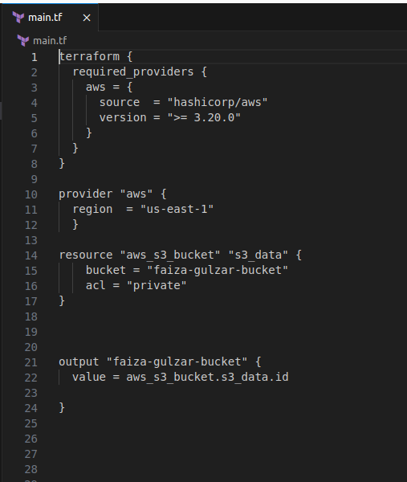

**Commands to run above main.tf to create bucket.**

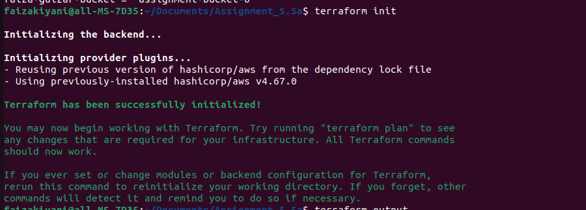

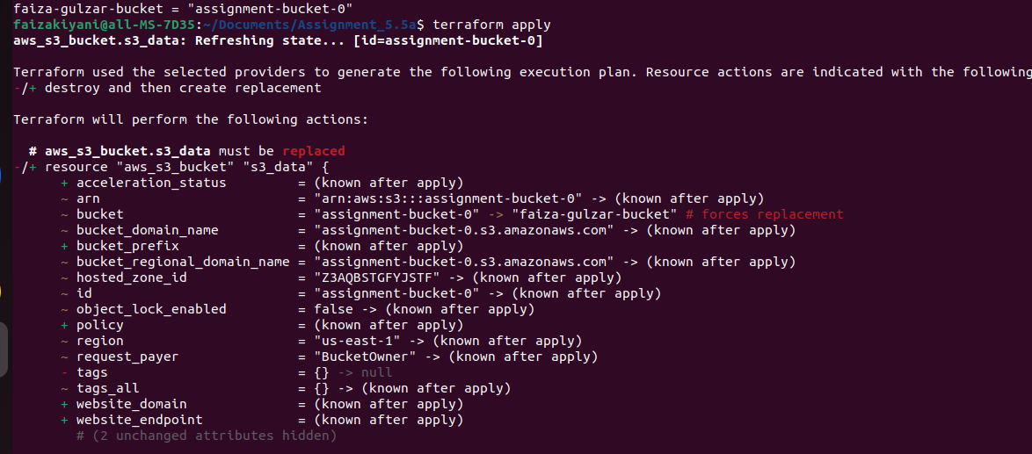

**Bucket is successfully created on AWS.**

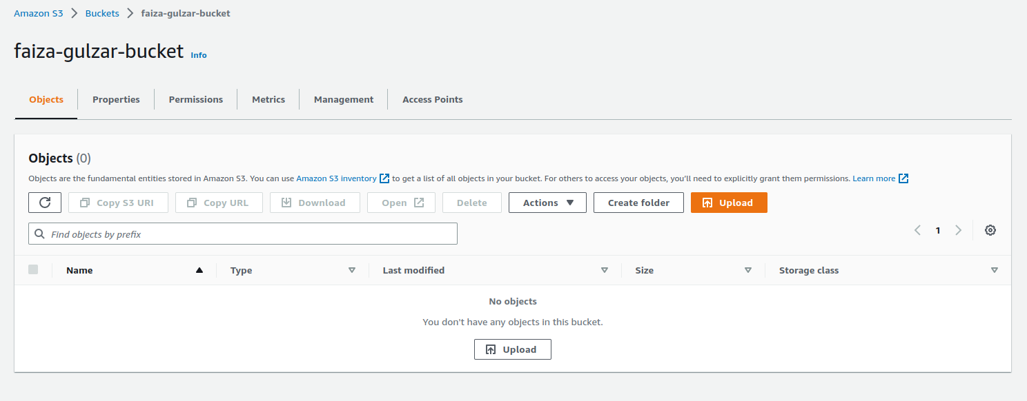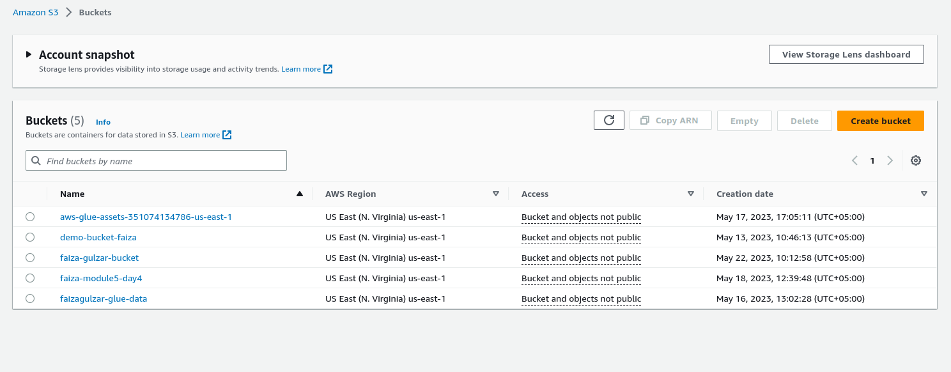

**Command to print id to the output**

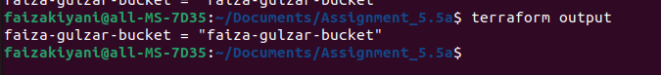

**Command to erase the bucket resources**

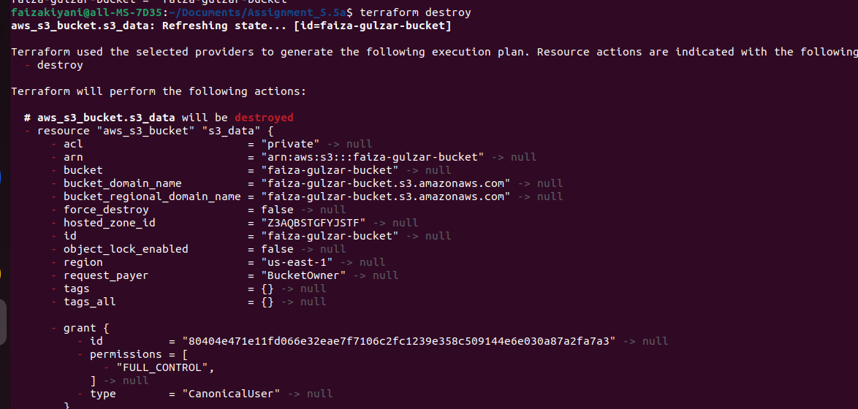

**All logs of apply and destory saved in txt files in current directory.**